Hands-on Visualization Task & Short Report:
Titanic Passenger Survival Analysis
Course: DCS402 Data Analytics & Visualization | Dataset: Kaggle Titanic (train.csv) | Topic: Graphical Perception
1. Introduction & Theoretical Background
Data visualization serves as the fundamental bridge between raw quantitative records and human decision-making. While tabular matrices accurately store numeric observations, human cognition struggles to synthesize raw numbers into intuitive patterns without visual transformation. Visual encodings convert abstract data into geometric attributes—such as spatial coordinates, lengths, slopes, angles, and surface areas—which the visual cortex decodes through rapid, pre-attentive perception. However, not all graphical encodings are decoded with equal precision. The seminal graphical perception research by William S. Cleveland and Robert McGill (1984) established that humans evaluate spatial positions along a common aligned scale with far greater accuracy than angles, arc lengths, or 2D circular sector areas. The primary objective of this report is to evaluate how different chart selections influence audience interpretation using the canonical Titanic passenger survival dataset.
2. Dataset Source & Analytical Methodology
Dataset Source: The data utilized in this study is the official Titanic: Machine Learning from Disaster training dataset (train.csv) obtained from Kaggle. The dataset contains demographic, socioeconomic, and travel records for 891 passengers aboard the ill-fated RMS Titanic in April 1912. The primary analytical target variable is 'Survived', a binary attribute where 0 denotes that the passenger perished and 1 denotes survival.
Methodology & Cleaning: The raw CSV file was imported and audited in Python using Pandas. Data exploration confirmed that all 891 records possess complete survival records (no missing values in the target variable). Data preprocessing involved mapping binary integers (0 and 1) to explicit, descriptive categorical labels ('Did Not Survive' and 'Survived') to eliminate audience ambiguity. Summary aggregations yielded exact counts and proportions: 549 passengers (61.62%) did not survive, whereas 342 passengers (38.38%) survived. Using Matplotlib and Seaborn, two contrasting charts—a Bar Chart and a Pie Chart—were generated to present this exact same distribution.
3. Figure 1: Passenger Survival Bar Chart
The bar chart represents passenger survival by assigning each categorical outcome to an independent column aligned along a shared horizontal baseline (y = 0). The vertical y-axis directly measures the absolute passenger count, while dual-annotation labels atop each column state both the raw frequency and corresponding percentage.
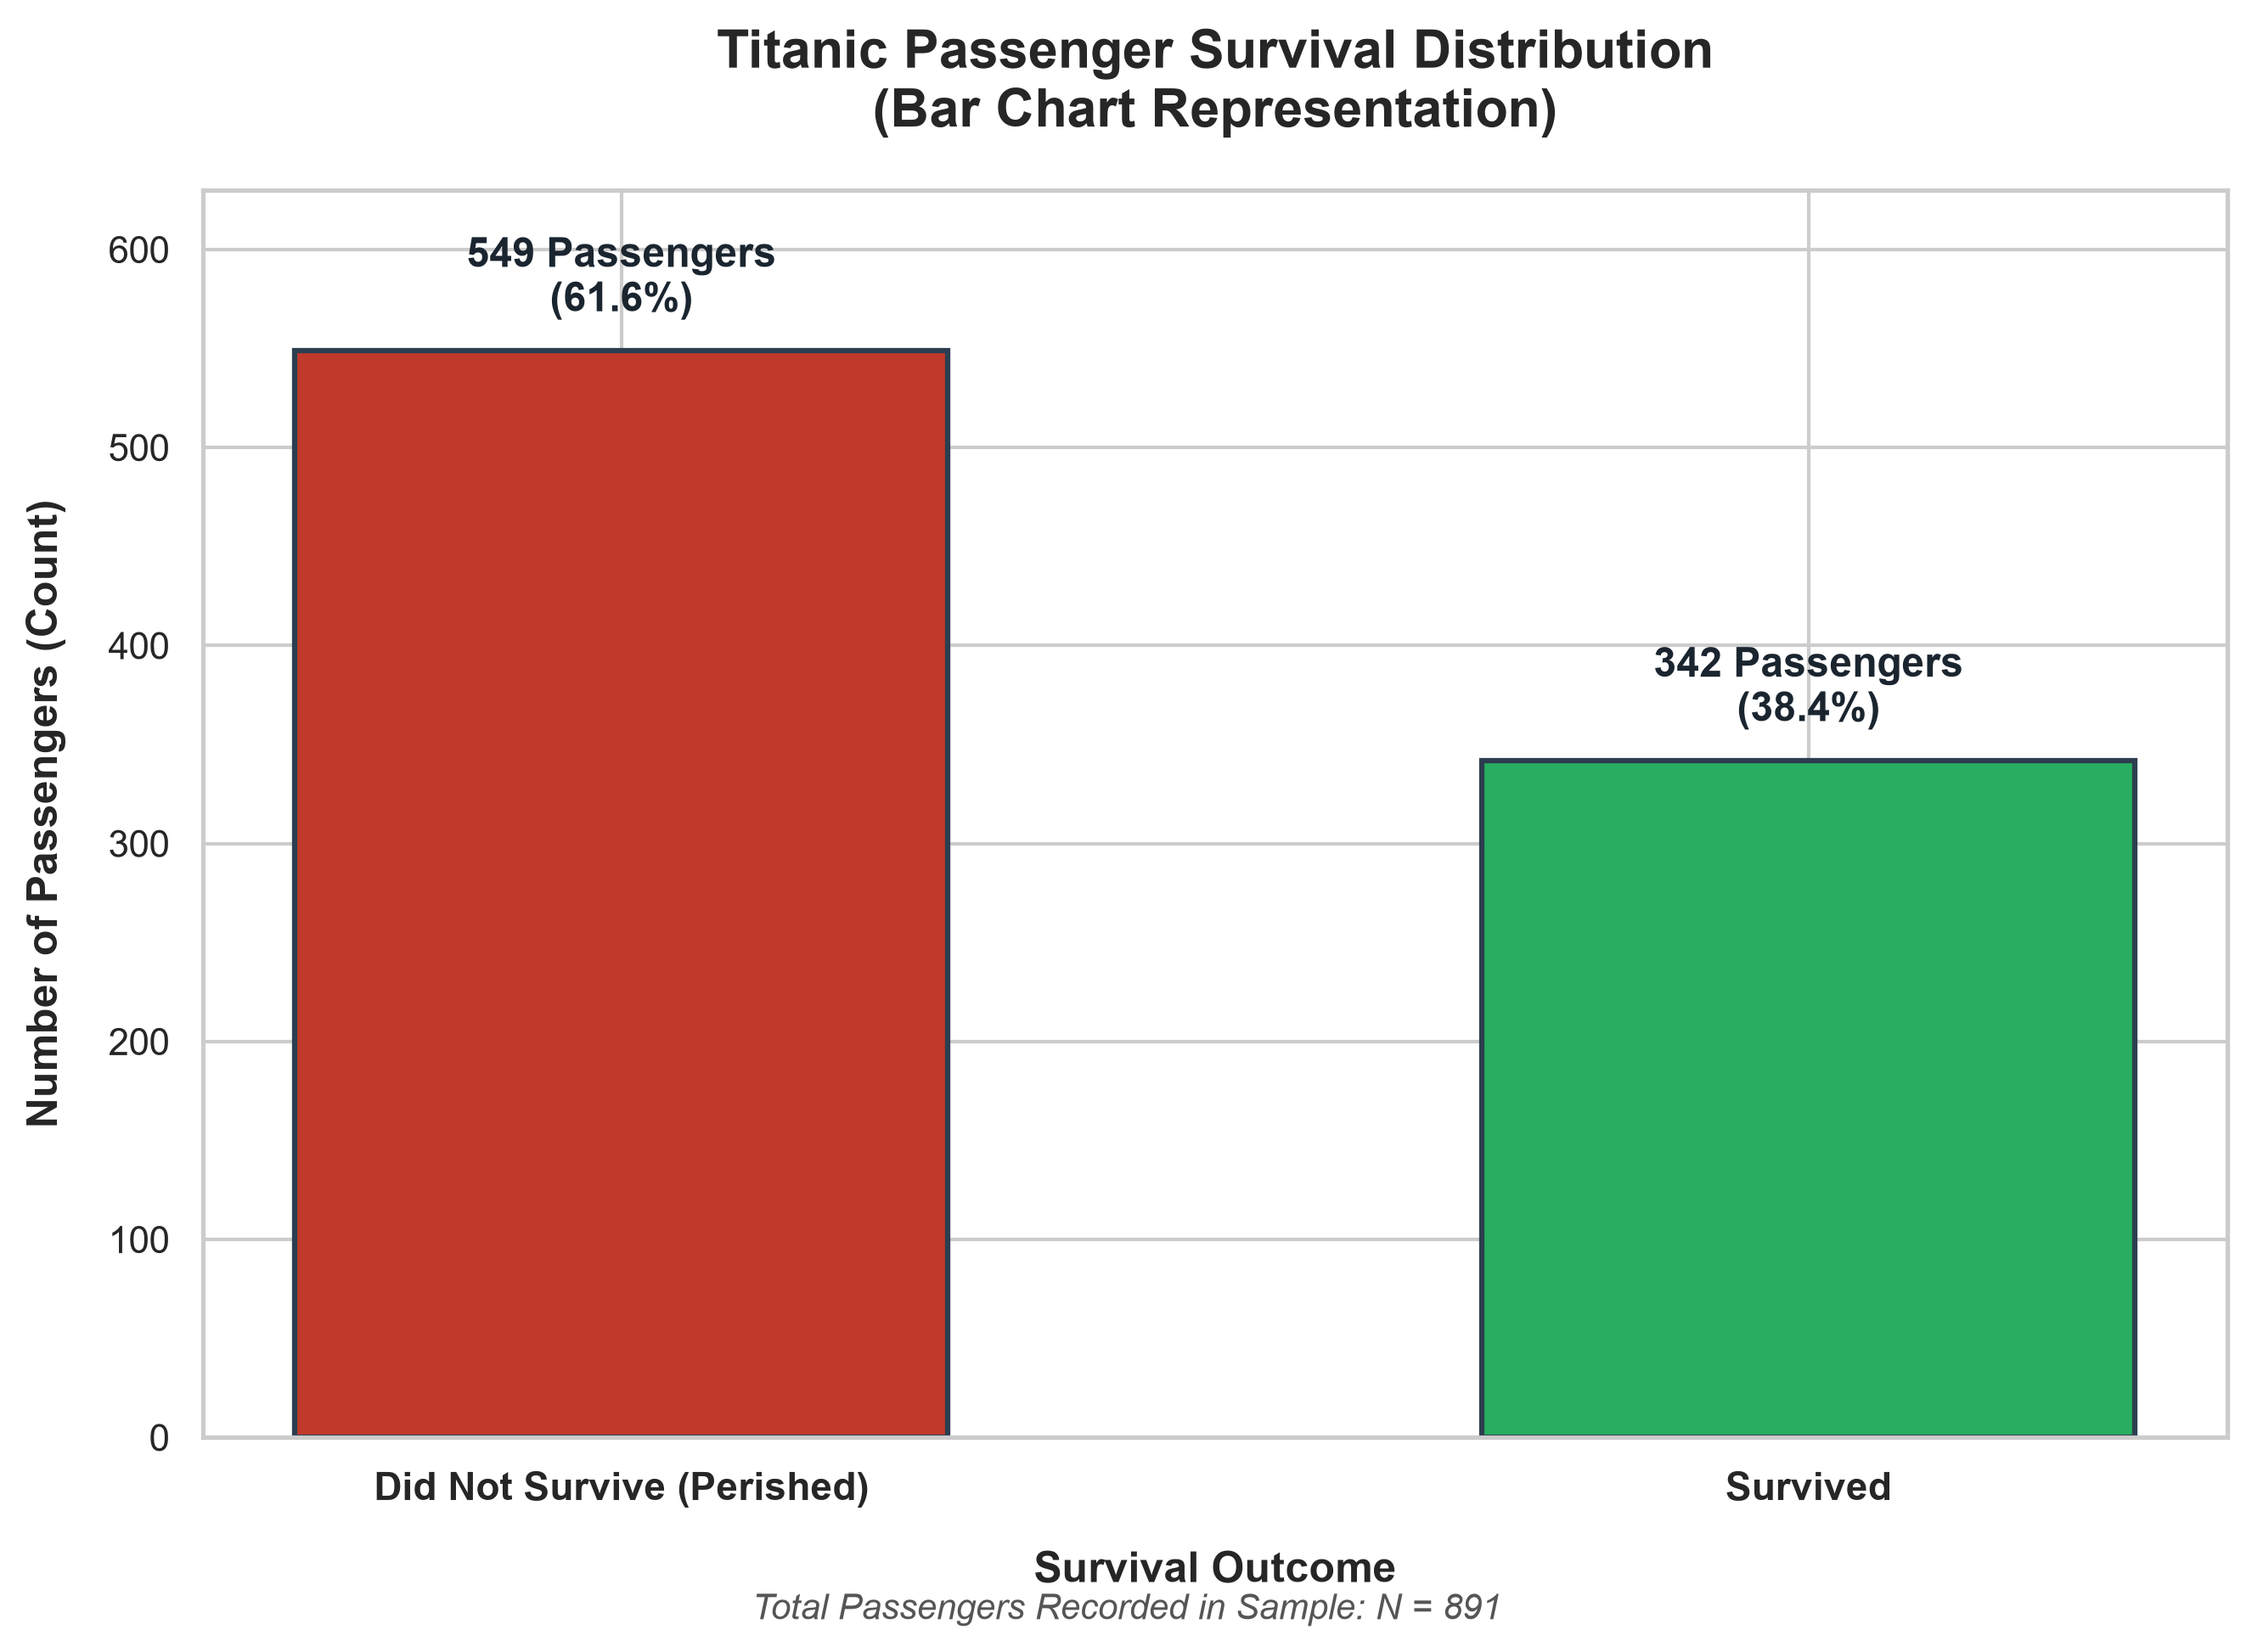
Figure 1: Distribution of Passengers by Survival Status (Bar Chart)
Audience Interpretation & Tradeoffs: Because both columns share an identical zero baseline, the audience can instantaneously gauge relative magnitude by comparing vertical heights. The visual height ratio of 549 to 342 (approx. 1.6:1) is immediately obvious. Viewers do not need to calculate mental ratios; the linear distance communicates the survival deficit within 200 milliseconds. Strengths: Maximum perceptual precision, clear numeric axis scale, easy labeling, and strong contrast. Limitations: It does not inherently visualize part-to-whole summation as naturally as a closed geometric shape, requiring numeric annotations to display percentage share.
4. Figure 2: Passenger Survival Pie Chart
The pie chart visualizes survival distribution as proportional sectors of a 360-degree circle. The full circular area represents the entire passenger cohort (N = 891 = 100%), while individual wedge angles correspond to the relative share of casualties (221.8 degrees = 61.6%) and survivors (138.2 degrees = 38.4%).
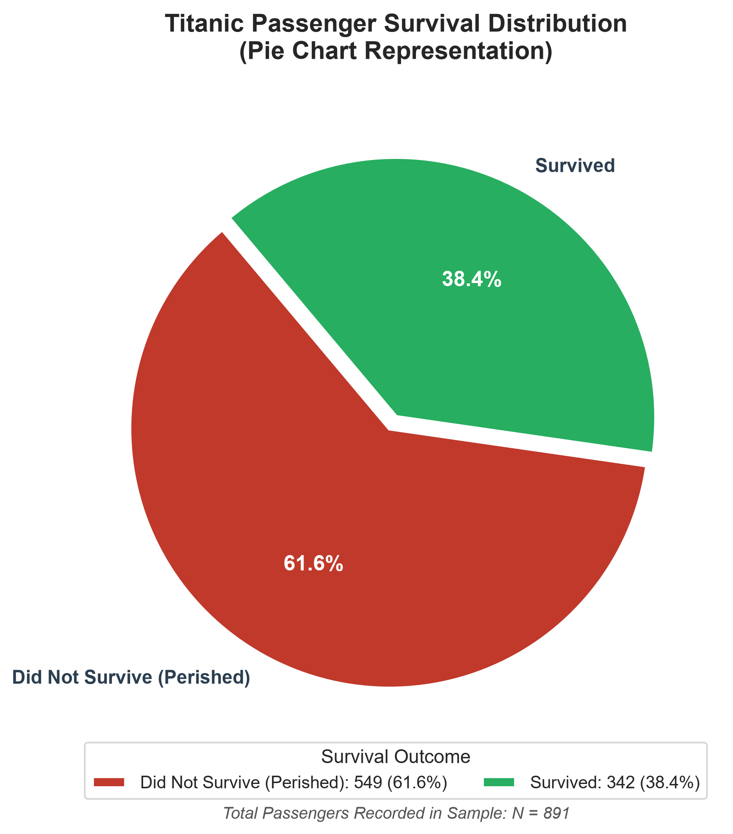
Figure 2: Proportion of Passengers by Survival Status (Pie Chart)
Audience Interpretation & Tradeoffs: The audience immediately perceives the part-to-whole relationship: the red sector clearly occupies well over half the circular space, intuitively conveying that non-survival was the dominant outcome. Strengths: Intrinsic part-to-whole framing and high familiarity in non-technical presentations. Limitations: The chart relies on human angle and area judgment, which suffers from psychological underestimation (Stevens' Power Law). Furthermore, reading exact passenger counts requires secondary text labels or an external legend, as radial wedges lack a calibrated metric axis.
5. Comparative Evaluation & Graphical Perception
Comparing the two visualizations demonstrates why chart selection is a crucial analytical decision rather than a cosmetic choice. In terms of graphical perception, the Bar Chart is demonstrably more effective for quantitative communication. According to Cleveland & McGill's perceptual hierarchy, human observers make judgments about position along a common scale with significantly less error than judgments about angles or 2D areas. In Figure 1, the bar chart allows the audience to immediately perceive that casualties exceeded survivors by over 200 individuals. In Figure 2, while the pie chart demonstrates that casualties formed the majority, determining the exact scale of that majority requires inspecting the written percentages.
Chart Type | Perceptual Mechanism | Key Strengths | Primary Weaknesses
Bar Chart  (Figure 1) | Position along aligned vertical baseline (Length) | • Instant height comparison  • Precise numeric scale  • Scalable to multiple categories  • Low cognitive fatigue | • Does not instinctively convey a 100% whole unless percentages are explicitly labeled
Pie Chart  (Figure 2) | Radial angles and 2D circular sector area | • Intuitive part-to-whole view  • Instantly conveys majority vs. minority (>50% visual cue)  • Compact visual footprint | • Prone to angular estimation error  • Lacks calibrated metric axis  • Fails when categories exceed 4–5
6. Conclusion & Recommendations
In conclusion, this hands-on visualization analysis illustrates that visual encodings directly dictate the efficiency and accuracy of audience interpretation. For the Titanic survival dataset, while the pie chart effectively illustrates that casualties constituted the majority share (61.6%), the bar chart is decisively more effective for analytical presentations. The bar chart preserves exact passenger counts along a calibrated baseline, eliminates perceptual angle distortion, and enables effortless quantitative comparisons. Data practitioners must always evaluate the analytical question, data structure, and cognitive perceptual hierarchy before selecting a visualization, ensuring charts illuminate rather than obscure critical findings.

